Onyx crm

Customization of Onyx with QlikView

Version: 7.7

September 2015

Contents

Before you Begin 1

Target Users 1

Prerequisites 1

Abbreviations 1

QlikView Files 2

Onyx_QVD_Generator.qvw 2

Onyx_Analytics.qvw 2

Database Permission and User Creation 2

Database Fields to support QlikView 3

Database configuration 3

Configuration File 3

Configuring Database 3

Modifying the Database Name and User 3

Modifying the Database Password 4

Start Year 5

Localization 5

Sales 6

Scripts 6

New Fields 6

Field Mapping 6

Alter Field Mapping 8

Sales status configuration 9

Sales Win/Loss configuration 10

Sales Booking 11

Sales Pipeline 11

Sales Close Date 11

Sales Weighted Pipeline 11

Sales Success Ratio 11

Sales Top Performers 12

Sales Reason for Win/Loss 12

Support 13

Scripts 13

New fields 13

Field Mapping 13

Alter Field Mapping 14

Support Status Configuration 15

Support First Contact Resolution 16

Security 16

Onyx UI Resources 16

QlikView Document: Create From Scratch 18

Adding New Sheet 18

Adding Graph with single/multiple dimension 21

Adding Filter Criteria 22

Changing Color of Chart 23

Changing Color and Font of text 24

Adding Multiple Languages (Localization) 26

# Before you Begin

This document provides the details for customization of Onyx with QlikView.

## Target Users

This document is intended for users with prior working knowledge of OnyxCRMproductsand QlikViewWorksheets(QVW) configuration.

## Prerequisites

Ensure that you have installed the following software:

* Aptean Analytics Setup_Win2012_1.0.0.8242
* Onyx CRM (OEP, OEAS, OGS)

## Abbreviations

The following abbreviations are used in the document:

OEAS : Onyx Enterprise Application Server

OEDB : Onyx Enterprise Transaction Database

OEP : Onyx Employee Portal

OGS : Onyx Gateway Service

QlikView Desktop : QlikView Desktop version 11.20 SR10 64Bit and above

QlikView Server : QlikView Server version 11.20 SR 10

# QlikView Files

Perform the following steps to customize Onyx with QlikView:

1. Organize the following files in QlikView server:

* Onyx_QVD_Generator.qvw
* Onyx_Analytics.qvw

1. Click **Reload**.

## Onyx_QVD_Generator.qvw

Onyx_QVD_Generator.qvw retrieves data from the database and stores in …\Onyx_QVDS folder with qvd extension.

**Note:** Add this file in QlikView server before adding Onyx_Analytics.qvw.

## Onyx_Analytics.qvw

Onyx_Analytics.qvw generates report from the data extracted from Onyx_QVD_Generator.qvw.

**Note:** Run Onyx_Analytics.qvw after the data is extracted from Onyx_QVD_Generator.qvw.

# Database Permission and User Creation

A User should be created with permission on tables and views on the Onyx Enterprise Database.

To create a User:

1. Run OnyxQlikViewDBSetup.sql file located in …\DBScripts folder on the Onyx Enterprise Database.

A User is created with permission on tables and views.

The same User is used by QlikView.

**Note:** To configure the database you have to modify the database name, User and password.

## Database Fields to support QlikView

To create fields to support QlikView:

1. Run QlikViewFields.sql file located in …\DBScripts folder on the Onyx Enterprise Database.

The Fields used by QlikView Reports are created by default.

# Database configuration

## Configuration File

The Onyx_Config.qvs file has the configuration for extraction of data from the Onyx Database such as the qualification of sales incident (sales won/lost data) and localization of reports.

## Configuring Database

To configure the database you have to modify the database name, User and password in the configuration file.

### Modifying the Database Name and User

To modify the Database Name and User:

1. Open the Onyx_Config.qvs file in notepad. The file is located in Onyx Analytics Installation Folder.

The following table illustrates the set of variables used for connection:

|  |  |
| --- | --- |
| Variable | Description |
| gvDBServer | Database server name or ip |
| gvOEBDDBName | Database name |
| gvDBUser | User used by QlikView uses to connect to database |
| gvSiteId | Onyx site id |
| gvLanguageCode | Onyx language code |

1. Modify the Database name and User in this file.
2. Save and close the file.

### Modifying the Database Password

For security reasons, password for the database is not placed in Onyx_Config.qvsfile. By default, the database password is set to **P@ssw0rd.**

To change the password:

1. Open the Onyx_QVD_Generator.qvw in QlikView desktop.
2. From **File** Menu, go to **Script Editor** and select **Edit** **Hidden Script**.

The password for Hidden script is **P@ssw0rd.**

1. Modify value of the variable **gvDBUserPassword** to change the password of the database.
2. Save and close the file.

# Start Year

The **start year** from when the data is to be extracted should be provided in the Onyx_Config.qvsfile.

Variable to define the start year is **gvDashboardStartYear**.

To modify the start year:

1. Open the Onyx_Config.qvs file in notepad.
2. Modify the value of the variable **gvDashboardStartYear** in this file.
3. Save and close the file.

Example:

If the data is to be extracted from the year 2005, modify the value of variable **gvDashboardStartYear** to 2005. By default the year is set to 2010.

# Localization

To localize the reports:

1. Open the Onyx_Config.qvs file in notepad.

The following table illustrates the sets of variables used for localization of the reports:

|  |  |
| --- | --- |
| Variable | Description |
| gvLanguageCode | Used to retrieve data from OEDB |
| gvLanguage | Used to localize the reports  Can accept following values:  English, Deutsch, Español, Français, 日本人 |

1. Modify the value of the variables **gvLanguageCode** and **gvLanguage** in this file.
2. Save and close the file.

* **Note:** The value of **gvLanguageCode** and **gvLanguage** should be set to the same localization.

# Sales

This section of the document explains the configuration and scripts required to load the sales data.

To enable Sales report feature:

1. Open the Onyx_Config.qvs file in notepad.
2. Modify the value of the variable **gvSales** in this file to **1**.
3. Save and close the file.

## Scripts

The sales related scripts are located in Onyx_Sales_QVS folder located in Onyx Analytics Installation folder.

Onyx_SalesIncidentsData.qvs file located in Onyx_Sales_QVS folder loads the data from the incident table.

## New Fields

The following table illustrates the list of fields added for the analytics reporting purpose:

|  |  |  |
| --- | --- | --- |
| Field | Name | Type |
| Incident. userQv1 | close_date | Datetime |
| incident.userQv2 | pipeline_stage | Int |
| incident.userQv3 | decision_date | Datetime |
| quote_header.userQv1 | close_probability | float |

## Field Mapping

The following table illustrates the mapping of OEDB and QlikView fields:

|  |  |  |
| --- | --- | --- |
| QlikView Field Name | Onyx Field Used | Comments |
| Incident Id | incident.incident_id |  |
| Incident Secondary Id | incident.secondary_id |  |
| Incident Product Code | incident.incident_product_code |  |
| Sales Incident Type Id | incident.incident_type_did |  |
| Sales Incident Status Id | incident.status_did |  |
| Employee Id | incident.assigned_to |  |
| Sales Incident Resolution Id | incident.resolution_did1 | Field is used to determine whether the opportunity is booking or pipeline |
| Sales Incident Resolution2 Id | incident.resolution_did2 | Field is used to enter reason for win or loss of opportunity |
| Incident Description | incident.desc1 |  |
| Sales Incident Priority Id | incident.priority_did |  |
| Incident Category Id | incident.incident_category_did | The incident categories are:   * Sales * Support * Service |
| Calendar Key | incident.userQv1, incident.insert_date | If incident is closed, it uses the incident.userQv1, else incident.insert_date |
| Incident Close Date | incident.userQv1 |  |
| Incident Close Difference Days | incident.userQv1, incident.insert_date | Difference between insert date and userQv1 |
| Incident Pipeline Stage Id | incident.userQv2 |  |
| Incident Decision Date | incident.userQv3 |  |
| Campaign Name | tracking_code_oa_view.campaign_desc |  |
| Country Code | address.country_code | Country code of the owner |
| Region Code | address.region_code | Region code of the owner |
| Customer Name | individualcompany.first_name + ' ' + individualcompany.last_name or company.company_name | Name of the owner |
| Quote Total | quote_header.total_cost1 |  |
| Quote Discount | quote_header.total_discount1 |  |
| Quote Close Probability | quote_header.user1 |  |
| Opportunity Value Group | quote_header.total_cost1 | Sum of total_cost1 segregated as following groups:   * Under 1 Million * 1-5 Million * Over 5 7Million |

## Alter Field Mapping

To change the field mapping of the newly created fields (**userQv1**, **userQv2** and **userQv3**) to desired fields:

1. **incident.userQv1** : **close_date**

Replace **incident.(userQv1)** to **incident.(fieldname)** in following file:

* Onyx_IncidentProductData.qvs located at …\OnyxAnalytics\Onyx_Sales_QVS\Onyx_Data

1. **incident.userQv2** : **pipeline_stage**

Replace **incident.(userQv2)** to **incident.(fieldname)** in following file:

* Onyx_IncidentProductData.qvs located at …\OnyxAnalytics\Onyx_Sales_QVS\Onyx_Data

For dimension:

Replace the reference field value variable

SET svSalesPipelineFieldName = 'incident.sales.userQv2'; in following file:

* Onyx_SalesPipelinestageData.qvs located at …\OnyxAnalytics\Onyx_Sales_QVS\Onyx_Map

The drop-down values available for the field are:

* Initial Step
* Research Customer Background
* Organize Meeting
* General Proposal
* Review Feedback
* Close Sale

1. **incident.userQv3** : **decision_date**

Replace **incident.(userQv3)** to **incident.(fieldname)** in following file:

* Onyx_IncidentProductData.qvs located at …\OnyxAnalytics\Onyx_Sales_QVS\Onyx_Data

1. **quote_header.userQv1** : **close_probability**

Replace **quote_header.(userQv1)** to **quote_header.(fieldname)** in following file:

* Onyx_IncidentProductData.qvs located at …\OnyxAnalytics\Onyx_Sales_QVS\Onyx_Data

## Sales status configuration

The Sales incident data is associated with status defined in the system.

The sales status is classified as:

* Open
* Pending
* Closed

The following status is defined in the system:

* Initial (101011)
* Research (101012)
* Lead Assessment (101013)
* Present Solution (101014)
* Proposal (101015)
* Implement (101016)
* Customer Care (101017)
* Closed (101018)

The sales status and system status mentioned above are segregated as:

**Open**

* Initial (101011)
* Research (101012)
* Lead Assessment (101013)

**Pending**

* Present Solution (101014)
* Proposal (101015)
* Implement (101016)

**Closed**

* Customer Care (101017)
* Closed (101018)

To define the above status:

1. Open the Onyx_Config.qvs file in notepad.
2. Define the value of the variables in this file.

The following table illustrates the value of the variable to be defined for the status:

|  |  |  |
| --- | --- | --- |
| Status | Variable | Value |
| Open | gvSalesIncidentStatusOpen | 101011,101012,101013 |
| Pending | gvSalesIncidentStatusPending | 101014,101015,101016 |
| Closed | gvSalesIncidentStatusClose | 101017,101018 |

1. Save and close the file.

## Sales Win/Loss configuration

The Sales incident data is classified as:

* Won
* Lost

The following status is defined in system:

* Fall Out (101200)
* Non-Renewal (101201)
* Won (101202)
* Lost (101203)

The sales incident data and resolution status mentioned above are segregated as:

**Win**

* Won (101202)

**Loss**

* Fall Out (101200)
* Non-Renewal (101201)
* Lost (101203)

To capture the status of sales data (either won or lost), the onyx field **incident.resolution_did1** is used; which is mapped to QlikView field **Sales Incident Resolution Id**.

To define the above status:

1. Open the Onyx_Config.qvs file in notepad.
2. Define the value of the variables in this file.

The following table illustrates the value of the variable to be defined for the status:

|  |  |  |
| --- | --- | --- |
| Status | Variable | Value |
| Won | gvSalesIncidentResolutionWon | 101202 |
| Lost | gvSalesIncidentResolutionLost | 101200,101201,101203 |

1. Save and close the file.

## Sales Booking

Sales booking data is determined by the QlikView field **Sales Incident Resolution Id**.

In the sales data reports, if the QlikView field **Sales Incident Resolution Id** is gvSalesIncidentResolutionWon, it is considered as **Sales** **Booking**.

## Sales Pipeline

Sales pipeline data is determined by the QlikView field **Sales Incident Resolution Id**.

In the sales data reports, if the QlikView field **Sales Incident Resolution Id** is Null and the status is not gvSalesIncidentStatusClose, it is considered as **Sales** **Pipeline**.

## Sales Close Date

To capture the close data of the sales incident, the Onyx field **incident.user1** is used; which is mapped to QlikView field **Incident Close Date**.

The following reports use this field:

1. Close Date and Incident Product (Booking)
2. Opportunities Closing List (Pipeline)
3. Opportunity Past Due List (Pipeline)

## Sales Weighted Pipeline

To capture the Sales Weighted Pipeline data, onyx field **quote_header.userQv1** is used; which is mapped to QlikView field **Quote Close Probability**.

To capture the weighted pipeline by stage data, multiply the QlikView field **Quote Close Probability** with **Quote** **Total**.

## Sales Success Ratio

To capture Sales success ratio, divide the QlikView field **Quote Close Probability** with **Quote Total**.

## Sales Top Performers

Top performers of sales assigned to is based on the **Quote Total** amount.

## Sales Reason for Win/Loss

To capture the reason for win or loss of a sale, onyx field **incident.resolution_did2** is used; which is mapped to QlikView field **Sales Incident Resolution2 Id**.

The following reports use this field:

1. Product – Sales Win/Loss
2. Opportunity Size – Sales Win/Loss
3. Industry – Sales Win/Loss
4. Country – Sales Win/Loss

# Support

This section explains the configuration and scripts needed to load the support data.

To enable Support report feature:

1. Open the Onyx_Config.qvs file in notepad.
2. Set **gvSupport** value to **1** in Onyx_Config.qvsfile.
3. Save and close the file.

## Scripts

The Support related scripts are located in Onyx_Support_QVS folder located in Onyx Analytics Installation folder.

Onyx_SupportIncidentsData.qvs file located in Onyx_Support_QVS folder loads the data from the incident table.

## New fields

The following table illustrates the list of fields added for the analytics reporting purpose:

|  |  |  |
| --- | --- | --- |
| Field | Name | Type |
| incident.userQv4 | first_contact_resolution | Int |
| incident.userQv5 | first_contact_datetime | datetime |

## Field Mapping

The following table illustrates the mapping of OEDB and QlikView fields:

|  |  |  |
| --- | --- | --- |
| QlikView Field Name | Onyx Field Used | Comments |
| Incident Id | incident.incident_id |  |
| Incident Secondary Id | incident.secondary_id |  |
| Incident Product Code | incident.incident_product_code |  |
| Support Incident Type Id | incident.incident_type_did |  |
| Support Incident Status Id | incident.status_did |  |
| Employee Id | incident.assigned_to |  |
| Support Incident Resolution Id | incident.resolution_did1 |  |
| Support Incident Resolution2 Id | incident.resolution_did2 |  |
| Incident Description | incident.desc1 |  |
| Support Incident Priority Id | incident.priority_did |  |
| Incident Category Id | incident.incident_category_did | 1. Support 2. Service 3. Sales |
| Calendar Key | incident.userQv1, incident.insert_date | If incident is closed, it uses the incident.userQv1 else incident.insert_date |
| Incident Close Date | incident.userQv1 |  |
| Incident Close Difference Days | incident.userQv1, incident.insert_date | difference between insert date and userQv1 |
| Country Code | address.country_code | Country code of the owner |
| Region Code | address.region_code | Region code of the owner |
| Customer Name | individualcompany.first_name + ' ' + individualcompany.last_name or company.company_name | Name of the owner |
| First Contact Resolution | incident.userQv4 |  |
| First Contact Duration | incident.userQv5 |  |

## Alter Field Mapping

To change the field mapping of the newly created fields (**userQv1**, **userQv4** and **userQv5**) to desired fields:

1. **Incident.userQv1** : **Close_date**

Replace **incident.(userQv1)** to **incident.(fieldname)** in following file:

* Onyx_SupportIncidentsData.qvs located at …\OnyxAnalytics\Onyx_Support_QVS\Onyx_Data

1. **incident.userQv4** : **first_contact_resolution**

Replace **incident.(userQv4)** to **incident.(fieldname)** in following file:

* Onyx_SupportIncidentsData.qvs located at …\OnyxAnalytics\Onyx_Support_QVS\Onyx_Data

1. **incident.userQv5** : **first_contact_datetime**

Replace **incident.(userQv5)** to **incident.(fieldname)** in following file

* Onyx_SupportIncidentsData.qvs located at …\OnyxAnalytics\Onyx_Support_QVS\Onyx_Data

## Support Status Configuration

The support incident data is associated with status defined in the system.

The support status is classified as:

* Open
* Pending
* Closed

The following status is defined in the system:

* Alerted (201011)
* Consulting Escalation (201012)
* Implementation (201013)
* Future Release (201014)
* Customer Resolved (201015)
* Pending Upgrade (201016)
* Researching (201017)
* Engaged (201018)
* Closed (201019)

The support status and system status mentioned above are segregated as:

**Open**

* Alerted (201011)
* Consulting Escalation (201012)
* Implementation (201013)
* Future Release (201014)

**Pending**

* Customer Resolved (201015)
* Pending Upgrade (201016)
* Researching (201017)
* Engaged (201018)

**Closed**

* Closed (201019)

To define the above status:

1. Open the Onyx_Config.qvs file in notepad.
2. Define the value of the variables in this file.

The following table illustrates the value of the variable to be defined for the status:

|  |  |  |
| --- | --- | --- |
| Status | Variable | Value |
| Open | gvSupportIncidentStatusOpen | 201011,201012,201013, 201014 |
| Pending | gvSupportIncidentStatusPending | 201015,201016,201017,201018 |
| Closed | gvSupportIncidentStatusClose | 201019 |

1. Save and close the file.

## Support First Contact Resolution

The support incident which is resolved on the first contact is captured in **incident.userQv4** field.

To capture the date and time of response **incident.userQv5** field is used.

# Security

**Onyx** and **QlikView** integration utilizes the onyx security for display of the reports.

To enable security variable:

1. Open the Onyx_Config.qvs file in notepad. The file is located in Onyx Analytics Installation Folder.
2. Set **gvSecurity** value to **1** in Onyx_Config.qvsfile.
3. Save and close the file.

## Onyx UI Resources

Every sheet in Onyx_Analytics.qvw is associated with UI resource.

The following is the list of UI resources mapped to sheets:

* gvSecuritySS01 = UI:ANALYTICS.SHEET.SS01
* gvSecuritySS02 = UI:ANALYTICS.SHEET.SS02
* gvSecuritySS03 = UI:ANALYTICS.SHEET.SS03
* gvSecuritySS04 = UI:ANALYTICS.SHEET.SS04
* gvSecuritySS05 = UI:ANALYTICS.SHEET.SS05
* gvSecuritySS06 = UI:ANALYTICS.SHEET.SS06
* gvSecuritySS07 = UI:ANALYTICS.SHEET.SS07
* gvSecuritySS08 = UI:ANALYTICS.SHEET.SS08

# QlikView Document: Create From Scratch

The following topics are described in this section:

* Adding new sheet
* Adding Graph with single/multiple dimension
* Adding Filter Criteria
* Changing color of Chart
* Changing color and font of text
* Adding multiple languages (Localization)

## Adding New Sheet

You can add a new sheet in the QlikView Developer Tool in two ways:

* You can load the template sheet where sample Sheet Objects are present and rename the sheet, or
* You can add a new sheet from the Layout present on the QlikView Developer Tool’s navigation bar.

To load a template sheet:

1. Open QlikView Developer tool.
2. Open an existing document.

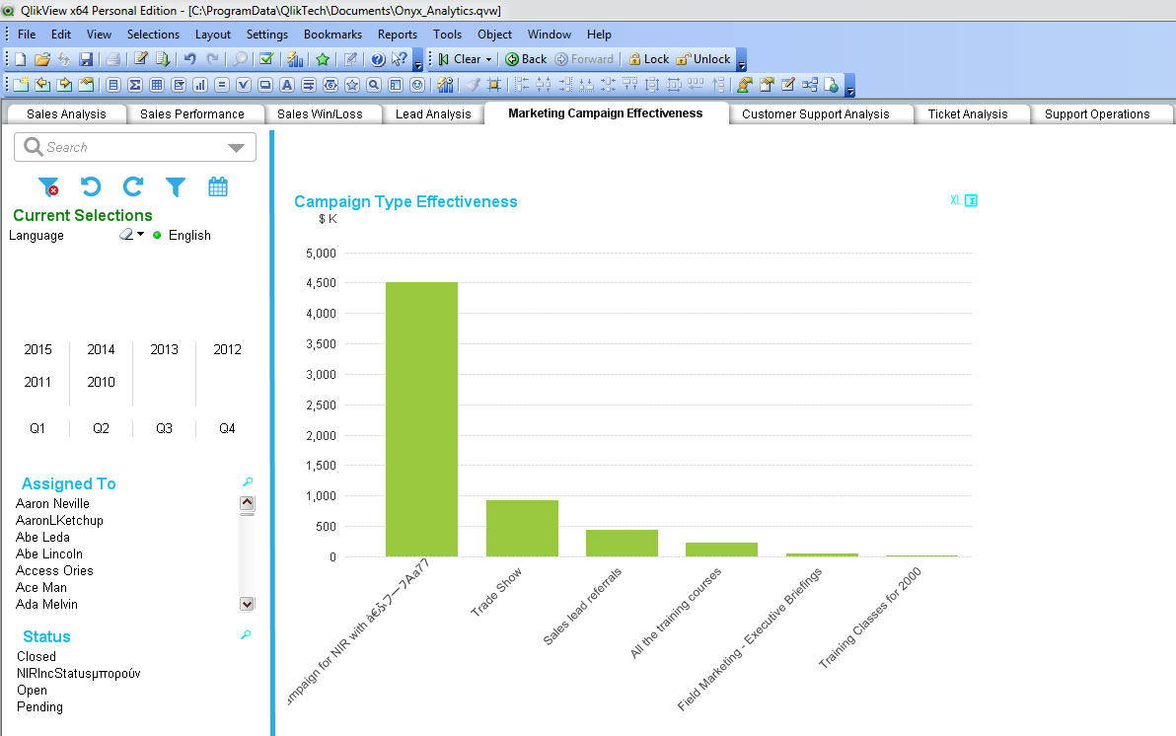

1. Press **Ctrl+Shift+S** to load the template sheet where sample Sheet Objects are present.
2. Remove the redundant sheet objects and retain the required objects.

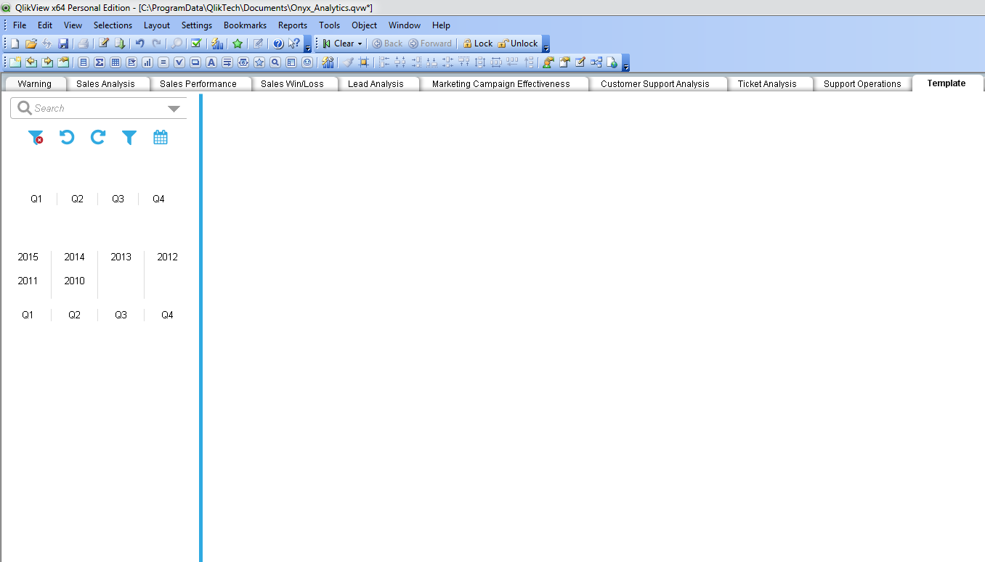

1. Rename the sheet.

Perform the following steps to rename the sheet:

1. Right click on the sheet and select **Properties**.
2. In the **Properties** window, select **General** tab and enter =Only({<[Label ID]={Label ID}>} Label) in **Title** field.
3. Change Label ID to your desired value.

Example: Onyx_SS09_name

1. Enter the Label ID (Example: Onyx_SS09_name) and Header (Example: Onyx_SS09_header) in Onyx_Labels.xlsx file located in QlikView Files folder and add the Usage Concatenated String for each Sheet.
2. To display the newly created sheet in **OEP**, add a menu item in the Config.xml file located in EmployeePortal root folder.

Location: …\Program Files\Onyx\EmployeePortal

Example:

<header:menuItem id="supportOperations"

ucf:uid="58E9AE9C-23AA-4DC9-891B-EF5826401B72"

popUp="0"

url=""

uiResource="UI:OEP.reports.analytics"

target="idFrameQlikViewReport"

targetArgument=

"document=Onyx_Analytics.qvw&sheet=SS08&hideTabs=true"

captionId="menu_supportOperations" />

1. To display the newly created sheet in **Analytics Web UI**, add the required details in the ASGAnalyticsMenuAndGroup.xlsm file:

* Menu Title
* Font Awesome Icon
* Sheet ID
* Sheet ID – Portrait
* Sheet Center Title
* Group
* Internationalized Name
* Internationalized Header
* Concatenated String for each Sheet

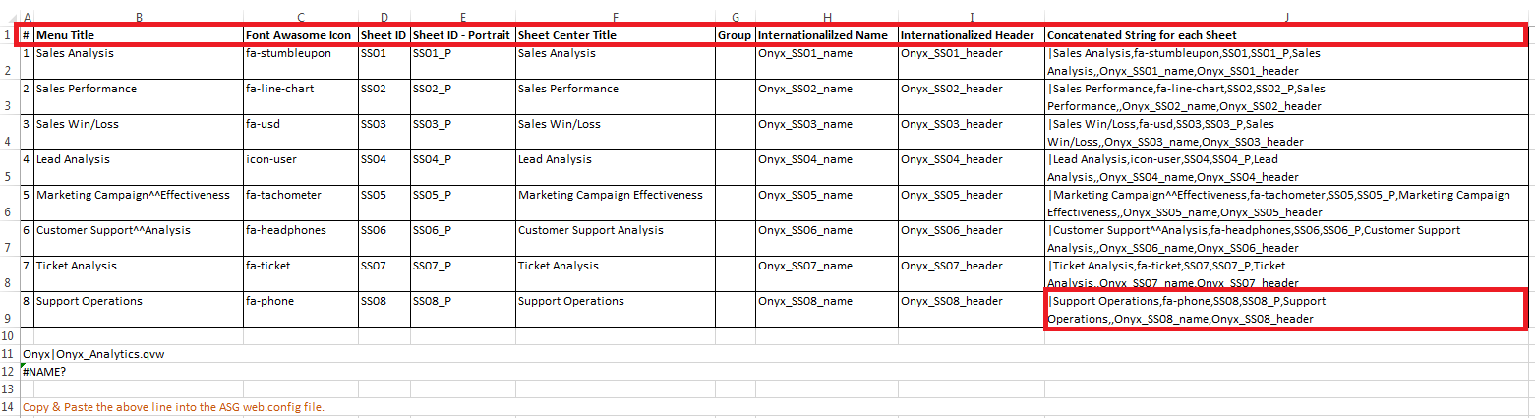

1. Add Concatenated String for the respective sheet in Web.config file to the key= BIConfigSettings.

Location: …\inetpub\wwwroot\ApteanServiceGateway

Example:

Sales Analysis,fa-stumbleupon,SS01,SS01_P,Sales Analysis,,Onyx_SS01_name,Onyx_SS01_header

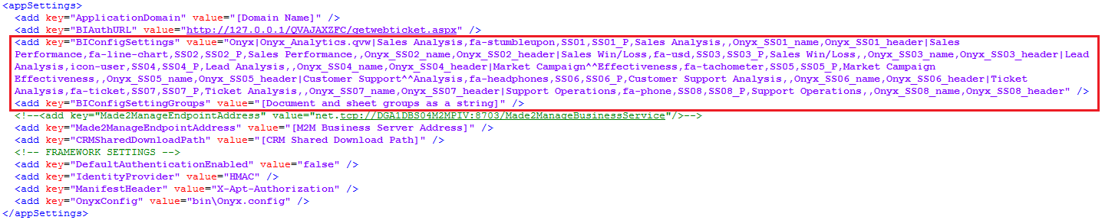

To add a new sheet:

1. From the Navigation Bar of the QlikView Developer Tool, click **Layout**
2. Click **Add Sheet**.

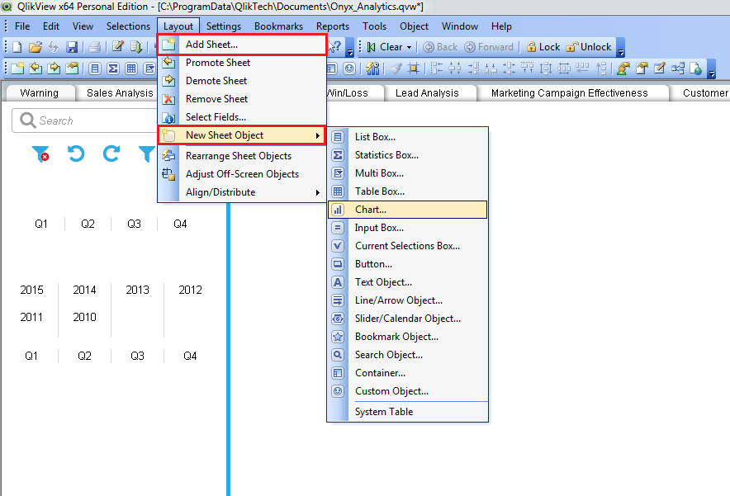

1. Repeat the steps 7-9 described in “To load a template sheet”.

## Adding Graph with single/multiple dimension

Perform the following steps to add graph with single/multiple dimension:

1. Right click on the sheet, from **New Sheet Objects** option select the required sheet objects.

The **properties** window of the selected sheet is displayed.

1. Enter the required details and click **OK.**
2. For charts, click **Next**.

The **Edit Expression** window is displayed.

1. Enter the details such as Dimensions, Expressions etc... and click **OK**.

Example: Expression for Total Quote with two dimensions, Campaign and Country is

=Sum([Quote Total])

* Note: Copy existing theme of the charts and other sheet objects prior to changing the Dimensions, Expressions and other required details.

## Adding Filter Criteria

Perform the following steps to add the filter criteria:

1. Right click on the sheet, from **New Sheet Objects** option select **List Box**.

The **List Box Properties (Priority)** screen is displayed.

1. In the **List Box Properties (Priority)** screen, under **General** tab enter the title value.

Example: =Only({<[Label ID]={Label ID}>} Label)

1. From dropdown in **Field**, select **<Expression>**.
2. Click **Edit**

The **Edit Expression** screen is displayed.

1. Enter the Expression and click **OK**.

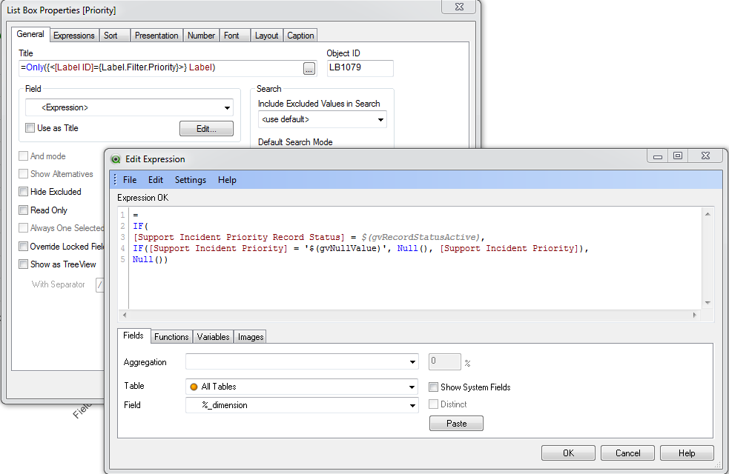

Example: Expression for Sales Priority is

=IF

([Sales Incident Priority Record Status] = $(gvRecordStatusActive),  
IF([Sales Incident Priority] = '$(gvNullValue)', Null(),

[Sales Incident Priority]),  
Null())

1. Enter the required details and click **Apply**.
2. Drag and Drop the **List Box** at the required position on the screen and click **Save**.

## Changing Color of Chart

Perform the following steps to change the color of chart:

1. Right click on the chart, select **Chart Properties**.

The **Chart Properties [Campaign Type Effectiveness]** screen is displayed.

1. From **Colors** tab, click **Advanced**.

The **Advanced Color Map** window is displayed.

You can retrieve, update or remove the color map for Sheet Default, Document Default, User Default and QlikView Default.

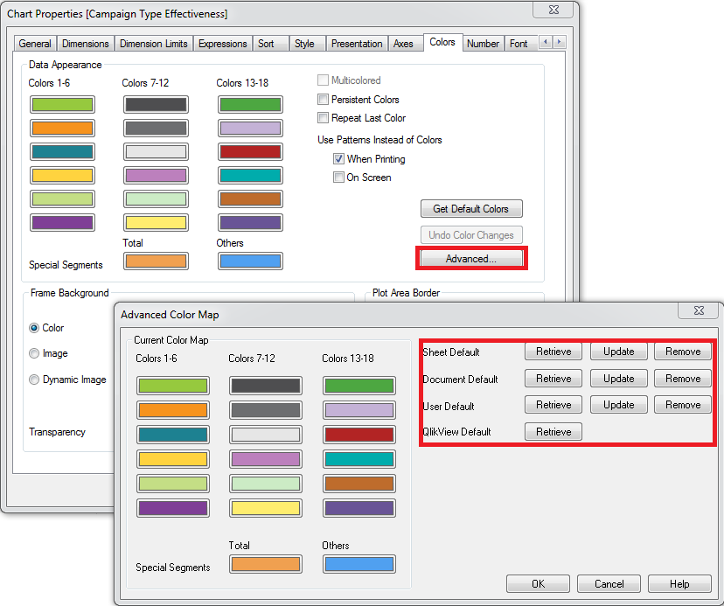

1. Click **Retrieve** to select the default color type and click **OK**.
2. Click **Apply** and click **OK**.

## Changing Color and Font of text

Perform the following steps to change font of text:

1. Right click on the chart, select **Chart Properties**.

The **Chart Properties [Campaign Type Effectiveness]** screen is displayed.

1. Enter **Title Text**.

Example:

=Only({<[Label ID]={Label ID}>} Label)

1. From **Caption** tab, click **Font** to change font, font style and font size.

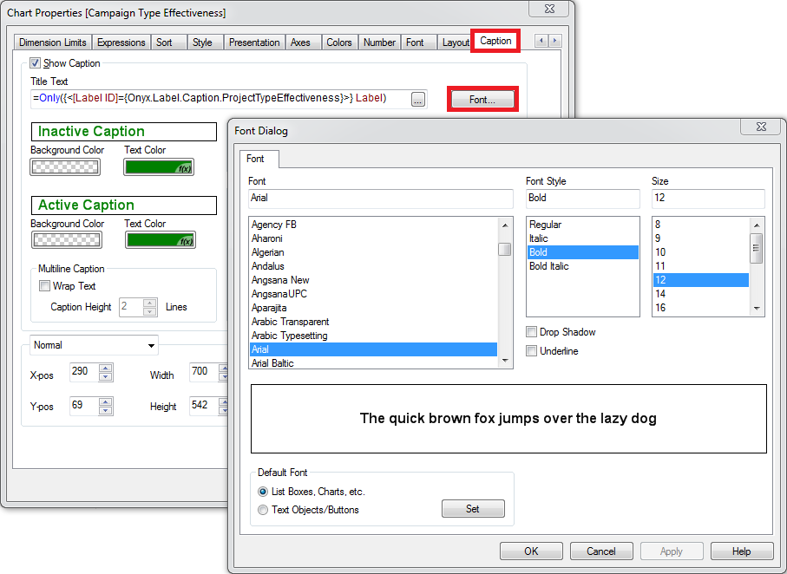

Perform the following steps to change color of text:

1. Right click on the chart, select **Chart Properties**.

The **Chart Properties [Campaign Type Effectiveness]** screen is displayed.

1. From **Presentation** tab, select **Color**.

The **Color Area** window is displayed.

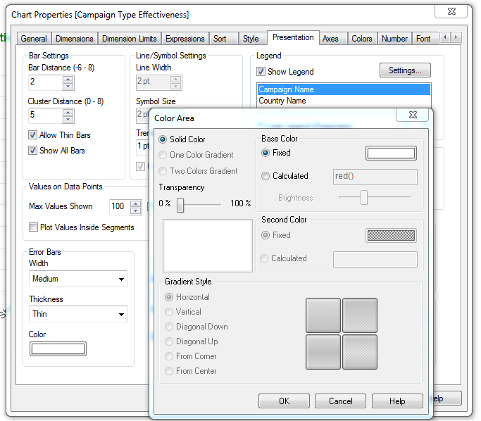

1. Set the color parameters and click **OK.**
2. **Apply** the changes and click **OK**.

Perform the following steps to display different colored text based on the upper limit and the lower limit:

1. Right click on the chart, select **Chart Properties**.

The **Chart Properties [Campaign Type Effectiveness] screen** is displayed.

1. In **Expression** tab, expand **Expression**, right click on **Text Color** and select **Edit Expression**.
2. From **File**, select **Colormix Wizard.**
3. Click **Next**.

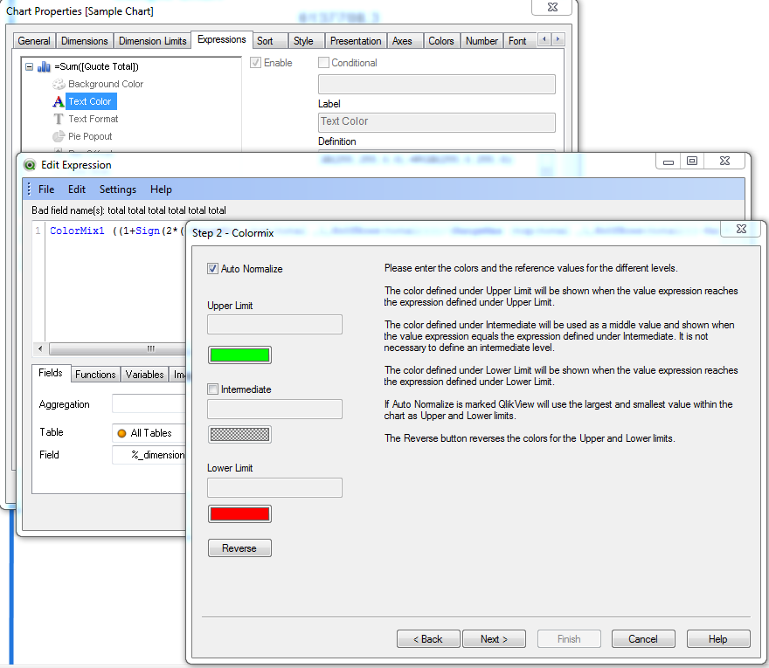

1. Set the Upper/Lower limit value color and click **Next**.
2. Select desired **Value saturation** and click **Finish**.
3. **Apply** the changes and click **OK**.

## Adding Multiple Languages (Localization)

Perform the following steps to add the multiple languages (Localization)

1. Open the file Onyx_Labels.qvs located at …\ProgramData\QlikTech\Documents.
2. Add a node for the required language in the file.

Example:

Concatenate (Labels)

LOAD [Label ID],

[CH] as Label,

'Chinese' as Language

FROM

Onyx_Labels.xlsx

(ooxml, embedded labels, table is 'Labels');

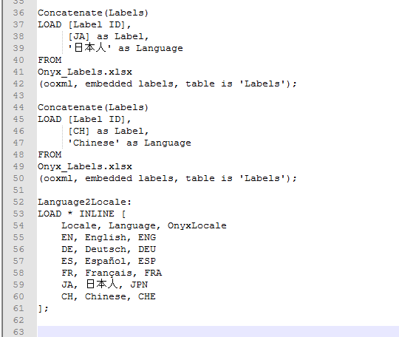

1. In **Language2Locale** section, add **Locale**, **Language**, **OnyxLocale** for the required language.

Example: CH, Chinese, CHE

1. Save Onyx_Labels.qvs file.

The language added is displayed in the list box of language in the **Filter Criteria** section.

1. Open Onyx_Labels.xlsx file and add an additional column for the newly required language.
2. Add text for the Containers, Labels and variables in Onyx_Labels.xlsx file.
3. Save the Onyx_Labels.xlsx file and reload the document to get the changes affected.

* **Note:** To display multiple languages for the Label/Container/Variable, fill the entire different languages column to display in all the different languages.